Peer 1 - Owen’s Mother who is studying ESL in our campus
I tested this app on my laptop. At first, the setup was difficult for me because I do not know how to use Docker, so I needed help to start the app. After the app was running, the interface was easy to understand. I could choose the microphone and see the English transcription and Chinese translation at the same time.
The transcription was useful because it helped me follow the English speaker better. However, it was not always perfect. Some words were recognized incorrectly and sometimes the sentence was cut off. The Chinese translation was mostly understandable, but sometimes it sounded unnatural or too simple. The speed was okay, but there was a small delay of a few seconds.
I think this app is helpful for ESL learners. I would use it in a real class, but I think the setup should be easier for people who are not computer science students.
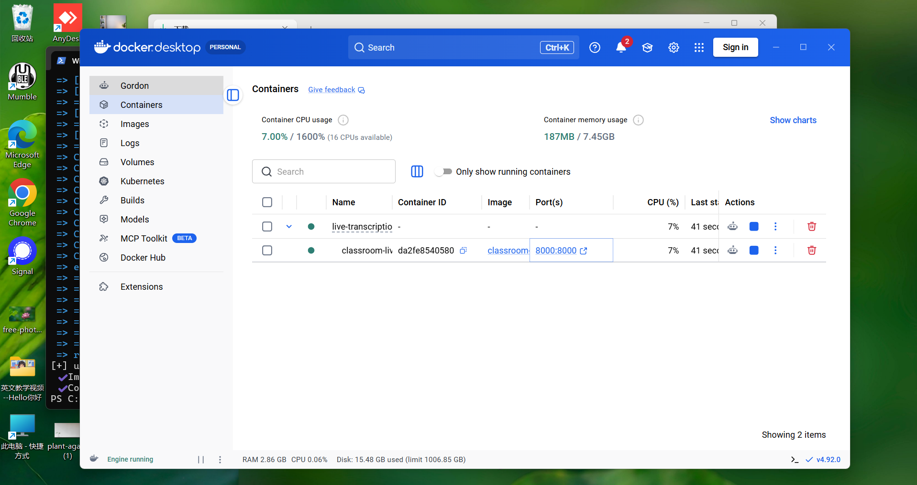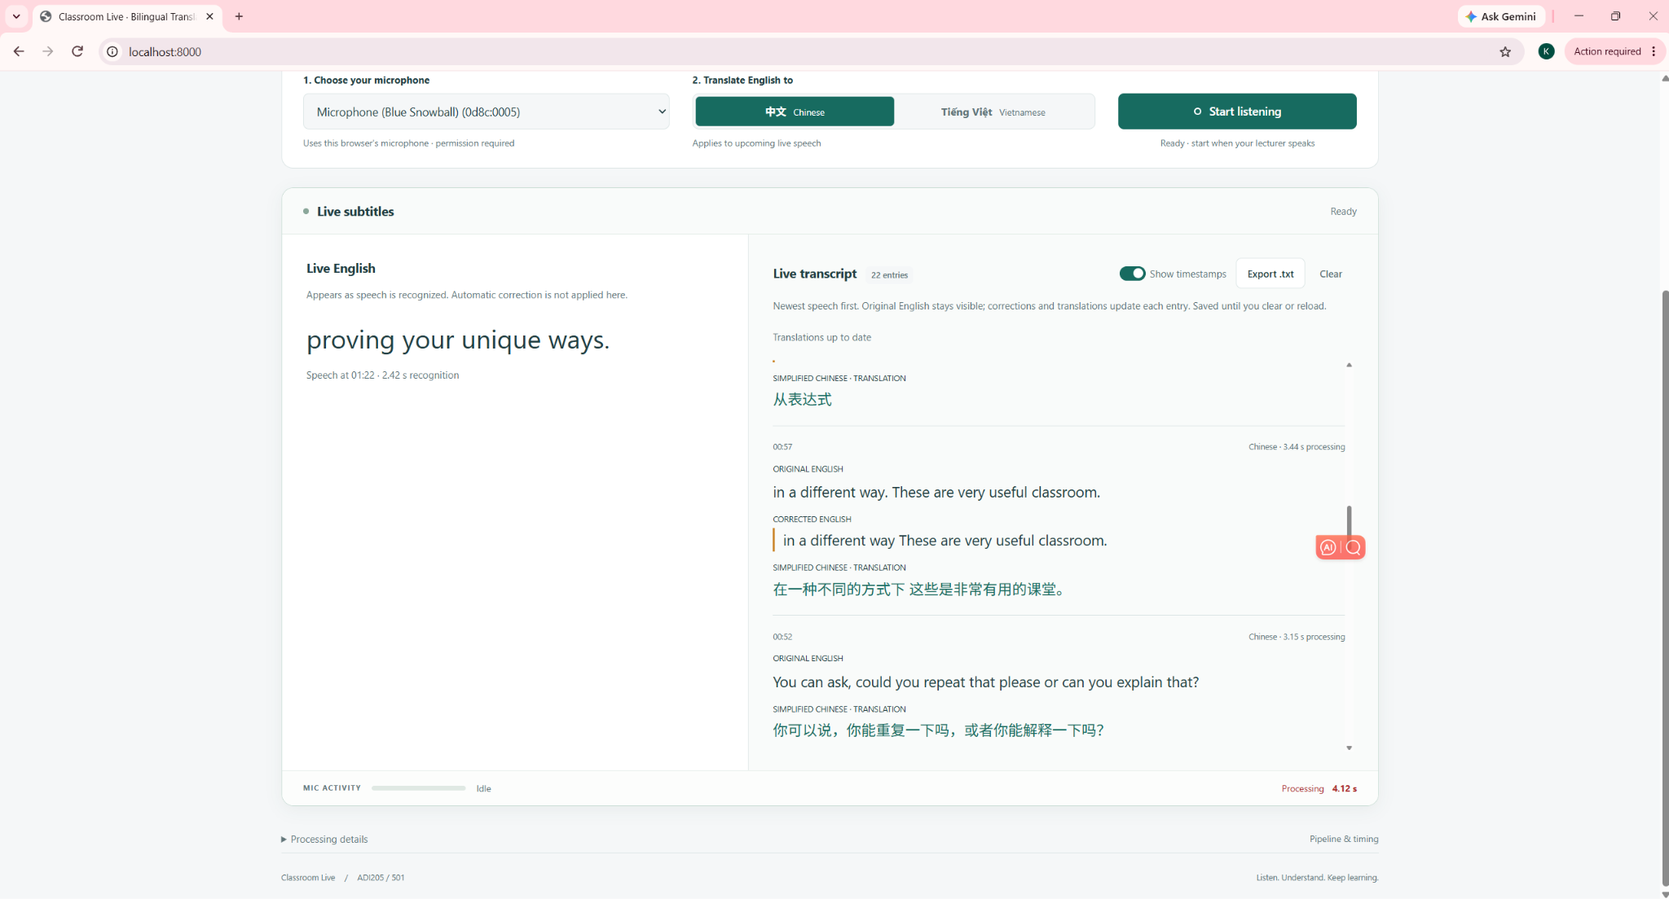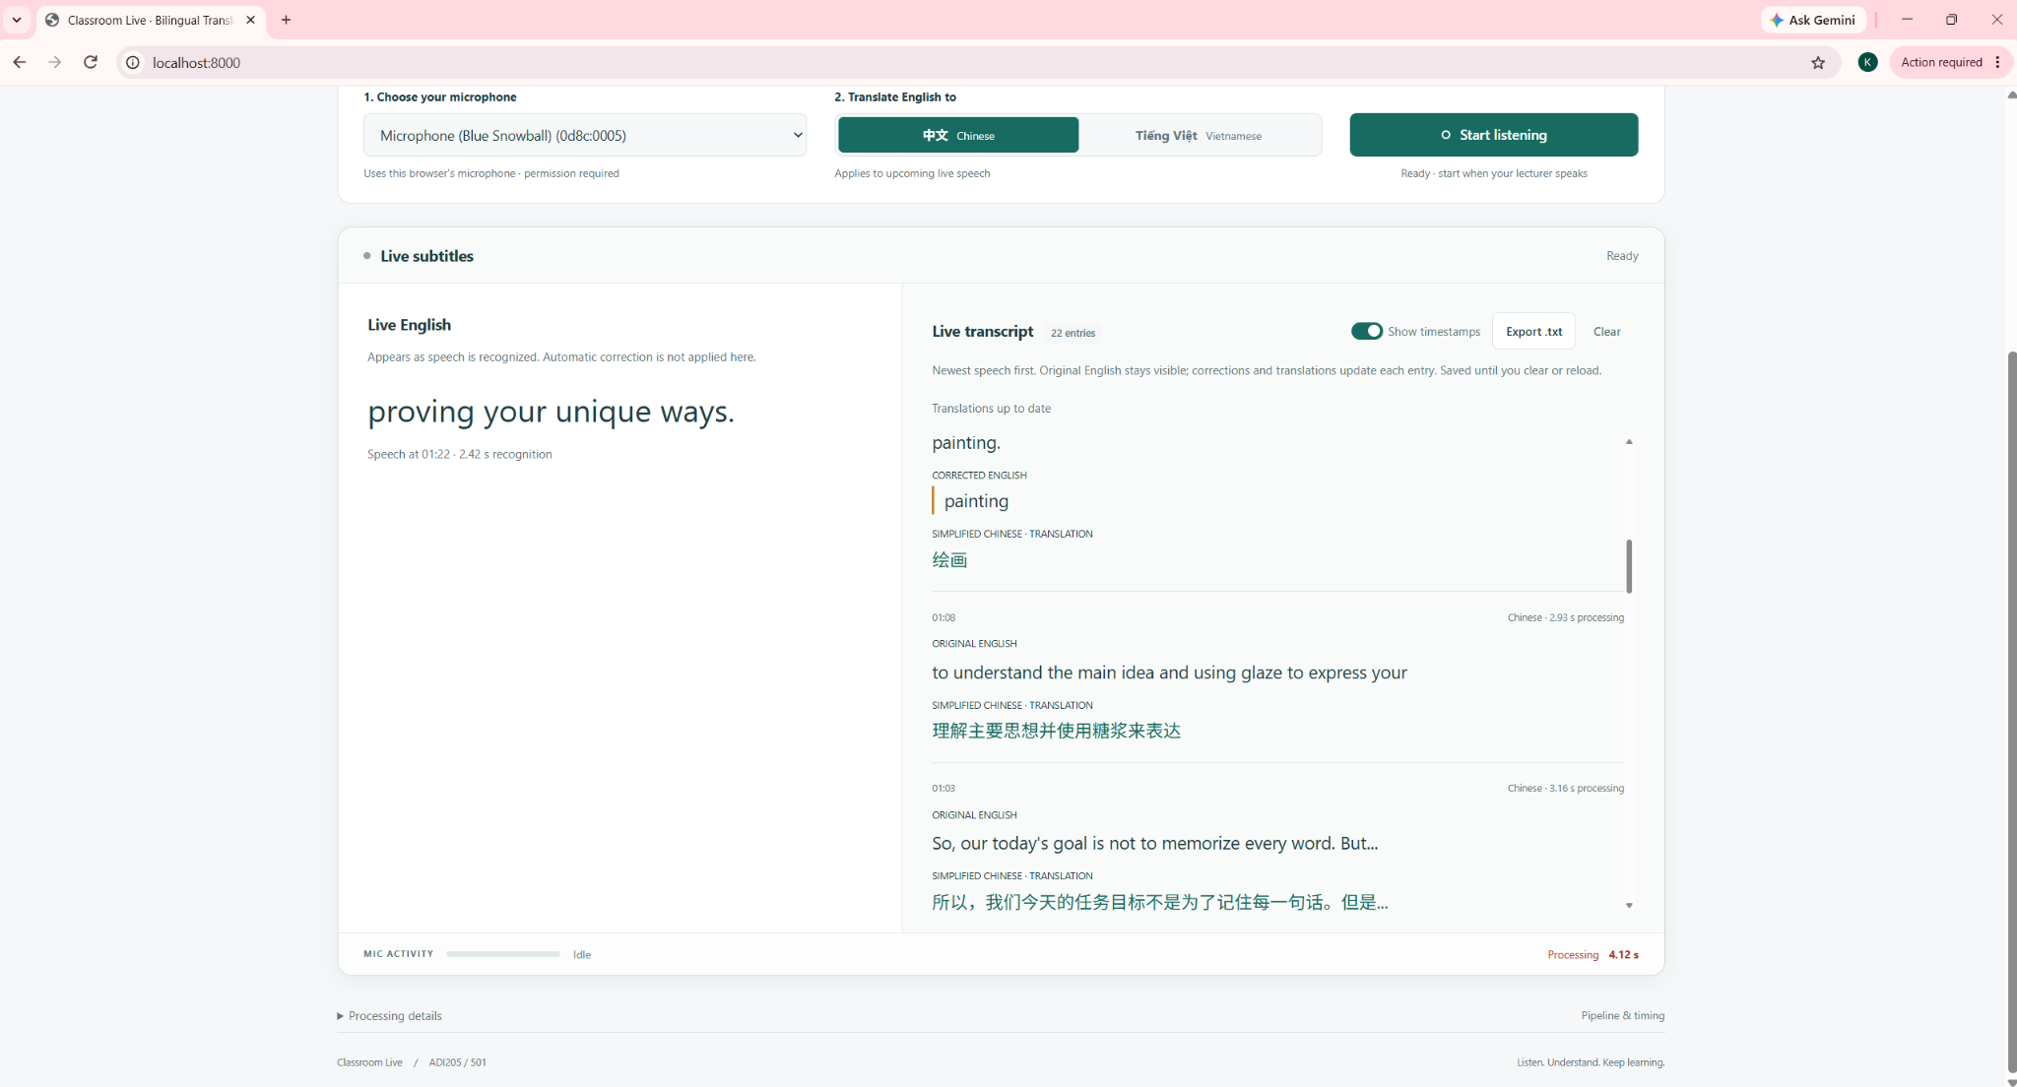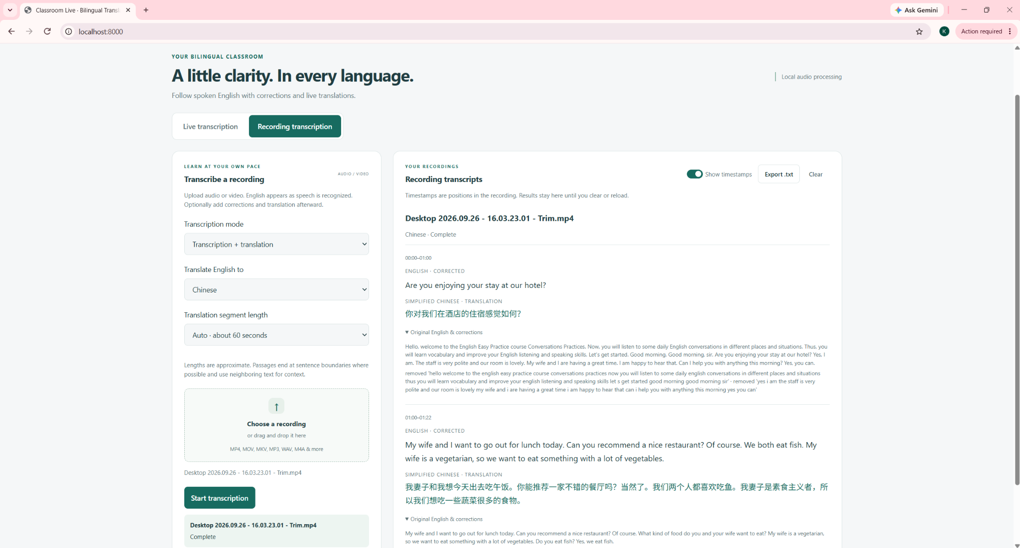

Peer 2 - Music
I'm a music student, so I don't have much experience with software like Docker. The setup was the hardest part, and I needed some help. Once it was running, though, everything was pretty simple. The app was easy to understand, and I could follow the live transcription without any trouble. It wasn't perfect, but it worked well most of the time. I think it would be useful for lectures or presentations.
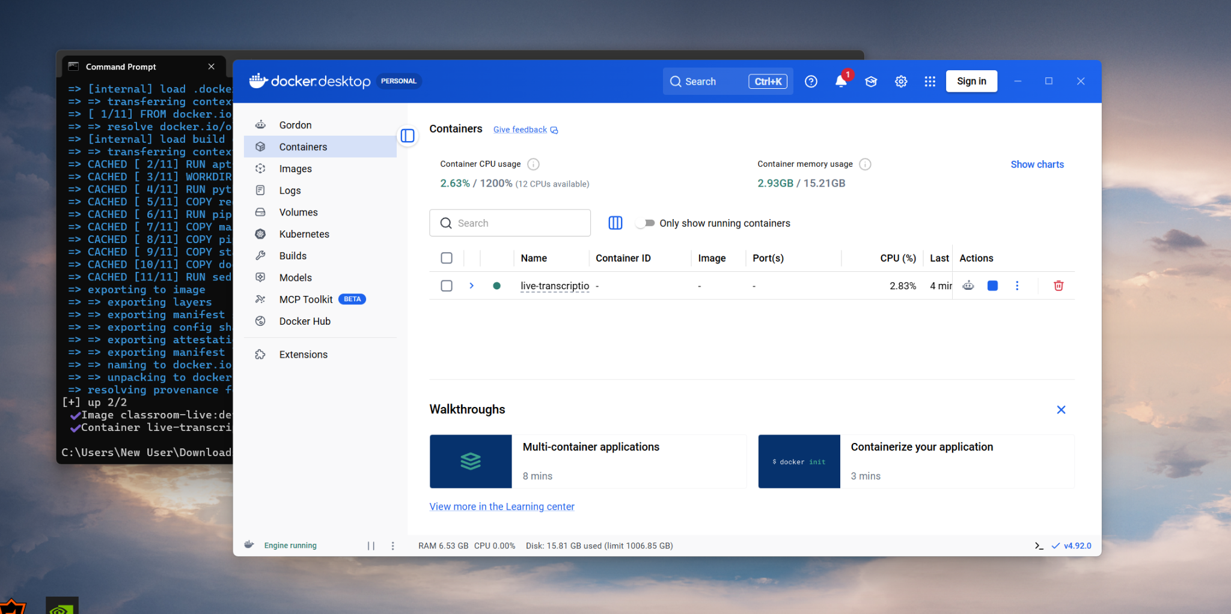
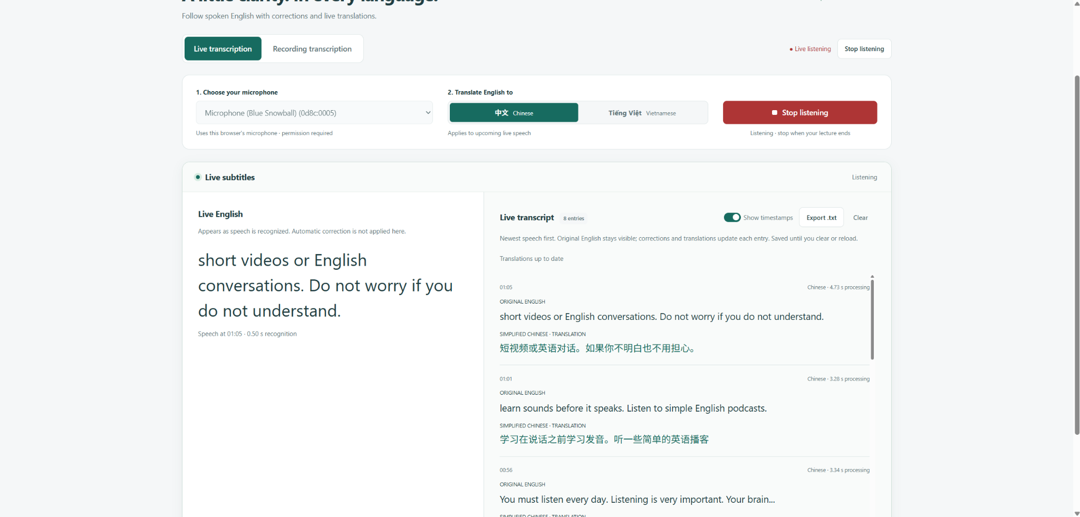

Peer 3 - Business Analysis
My friend showed me this app on his laptop, so I didn't have to install it myself. The idea is interesting, but I noticed quite a few issues while watching the demo. The transcription was sometimes delayed, and a few words were recognized incorrectly. The translation also wasn't always accurate, especially with longer sentences. I think the interface is simple and easy to understand, but the app still needs some improvements before I would use it regularly. Overall, it has potential, but I think it needs to be more stable and accurate.
